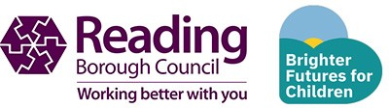

Primary Schools Designated Areas (Catchments) for Primary, Infant and Junior Schools in Reading for the
2027/2028 academic year.

For September 2027 entry Determined on

The maps on the following pages show the primary school catchment areas. It includes catchments for Reading Borough Council maintained and other state maintained schools.
Please note, not all schools have a catchment area.
Some areas do not have a catchment school due to schools removing the catchment criteria from their policy.
The maps do not include parish catchments for schools. A parish catchment is an address which falls in the area of an ecclesiastical parish church.

