Bike Hangar Pilot Scheme – Suggesting Possible Locations
Thank you for your interest in the Reading Borough Council Bike Hangar Pilot Scheme.
We are inviting residents to suggest locations where they believe a bike hangar could be installed. Your local knowledge is invaluable in helping us identify sites that are convenient for residents while being safe and practical to install.
Please note that all suggested locations will be subject to a technical assessment by the Council. A suggested location does not guarantee that a bike hangar can be installed there.
What makes a good location?
When suggesting a location, please consider whether it:
- Is close to the homes of the people who would use it.
- Is safe and convenient to access by bike.
- Does not obstruct visibility at road junctions or crossings.
- Maintains safe access for pedestrians, wheelchair users, people with pushchairs and those with mobility impairments.
- Does not block driveways, dropped kerbs, utility covers or emergency access.
- Can be accommodated without creating road safety concerns.

Below, you will find examples of possible locations that may be considered, however, we are seeking further suggestions from residents.

Location: Amity Street (Newtown)
Reason for suggestion: After the site visit, the section of double yellow lines are approximately 20 metres in length, which would still permit the queuing of up to three vehicles where necessary, without causing significant obstruction.
It is therefore considered that the proposed cycle hangar would be more suitably located closer to the width restriction island. This revised positioning would provide improved access and egress to Amity Road, while maintaining adequate carriageway functionality and minimising any potential impact on traffic flow.
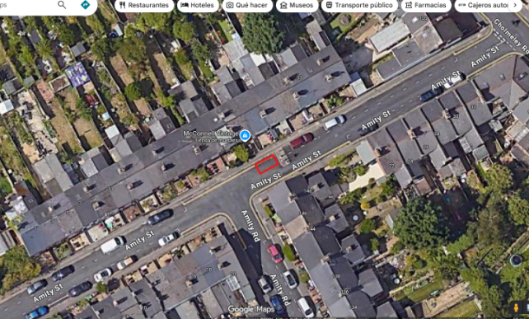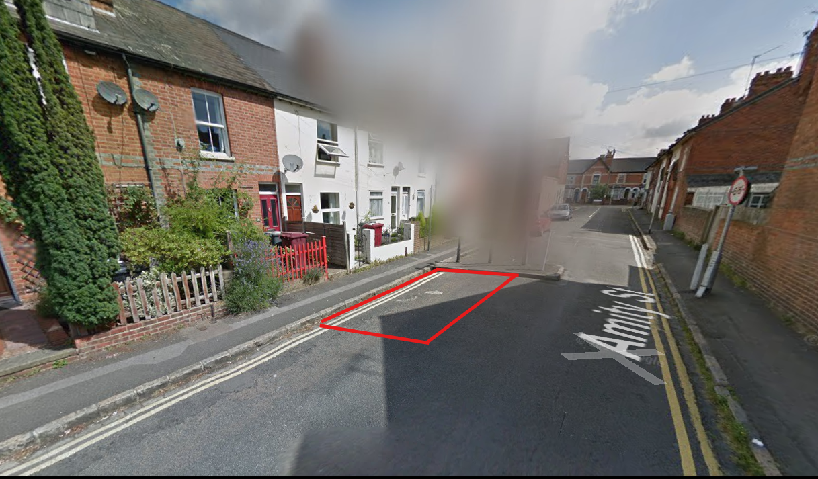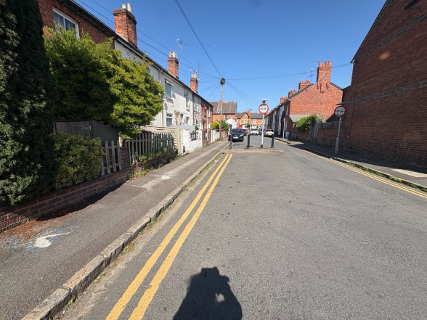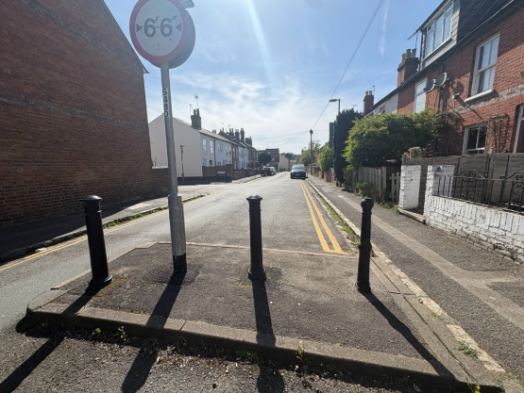
Location: Whitley Street
Whitley Road is a suitable location for the installation of a cycle hangar due to the generous width of the footway. The available space allows the cycle hangar to be accommodated while maintaining sufficient clear pedestrian access and ensuring that both pedestrians and cyclists can continue to use the area safely and comfortably.
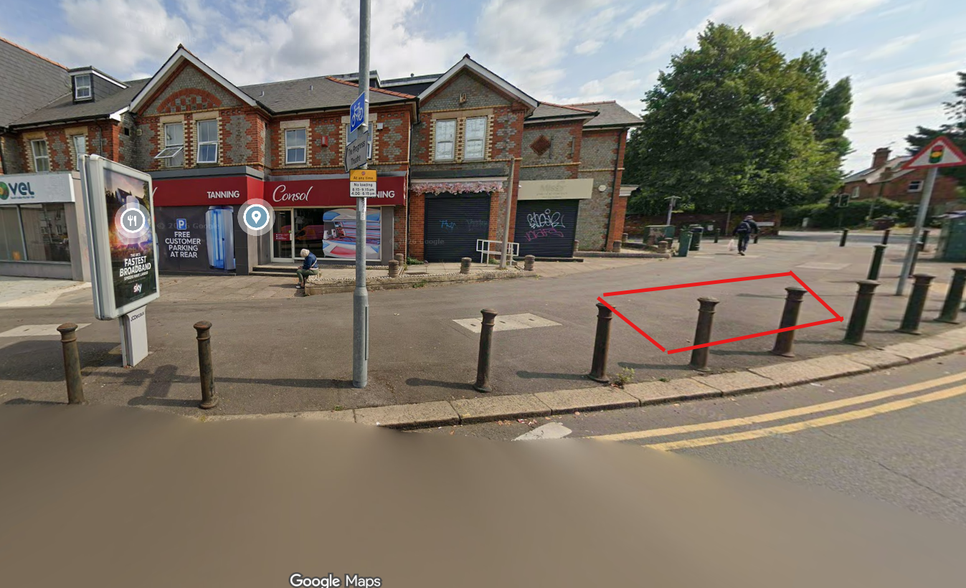
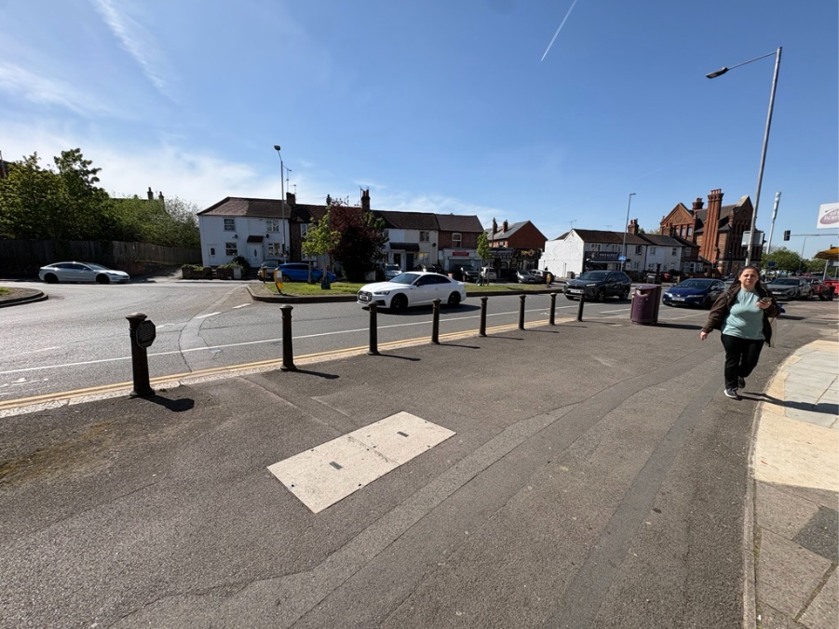

What happens next?
Once suggestions have been received, officers will assess each location against a range of criteria, including:
- Road safety and visibility.
- Highway and footway widths.
- Accessibility for pedestrians and wheelchair users.
- Existing parking restrictions.
- Underground utilities and other street furniture.
- Demand from local residents.
- Practicality of installation and future maintenance.
Where a location is considered suitable, it may be included within the Bike Hangar Pilot Scheme, subject to funding, detailed design and any necessary approvals.
The Council will provide further information to residents once the location have been confirmed.
Thank you for helping us identify suitable locations for secure cycle parking in Reading.

